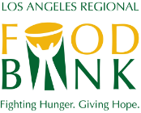

Contact:
Amy Hasquet
Director of Annual Giving
(323) 234-3030 ext. 140
ahasquet@lafoodbank.org

#WeFeedLA 2023 - Social Media Toolkit

The Los Angeles Regional Food Bank is honored to have your participation in the Food Bank’s fundraising program for those who want to raise awareness and funds from their network of family, friends and colleagues to help food-insecure individuals in Los Angeles County!

By contributing to the conversation surrounding this hunger initiative on social media, you engage your online community to support food-insecure children, seniors, families and individuals in our shared community. Each person you inspire to donate and get involved through your social media networks brings us closer to closing the hunger gap in LA County.

The purpose of this toolkit is to provide readily accessible information, pre-written messages and other resources that will make our collaboration simple and successful.

This toolkit includes:
· General information about the Los Angeles Regional Food Bank
· General information about #WeFeedLA
· Sample social media posts and information regarding the official hashtag and other assets

We thank you for joining us as we fight food insecurity and work to close the hunger gap in our community. You are a Hunger Hero!

Sincerely,
Julianna Jaynes

General Information: Los Angeles Regional Food Bank

Mission
To mobilize resources to fight hunger in our community.
To fulfill our mission, we:
- Source and acquire nutritious food and other products and distribute them to people experiencing nutrition insecurity through our partner agency network and directly through programs;
- Energize the community to get involved and support hunger relief;
- Conduct hunger and nutrition education and awareness campaigns and advocate for public policies that benefit the people we serve.

Our Vision:
No one goes hungry in Los Angeles County.

About the Los Angeles Regional Food Bank:
The Los Angeles Regional Food Bank has been mobilizing resources to fight hunger in Los Angeles County since 1973. To support the Food Bank’s vision that no one goes hungry in Los Angeles County, food and grocery products are distributed through a network of 600+ partner agencies and through Food Bank programs serving 800,000 people monthly. In response to the COVID-19 pandemic, the Food Bank tripled the number of people reached every month. The Food Bank is a 4-star rated charity by Charity Navigator. For more information, visit LAFoodBank.org.

Food Bank: Fast Facts
- The Food Bank distributes more than four million pounds of food each week and serves more than 800,000 people each month.
- We have distributed enough food for more than 1.6 billion meals since 1973.
- The Food Bank distributes food through more than 600 partner agencies and directly through Food Bank programs.
- Your gift can multiply in impact when combined with other cash donations, purchased and donated foods, so that 96% of every dollar goes back to the community.
- Our work is good for the environment. The food donated by retailers is perfectly good food that, oftentimes, would otherwise end up in a landfill.

General Information: #WeFeedLA
#WeFeedLA and its online fundraising platform continue to empower so many in our community to virtually help their neighbors in need and energize their networks to get involved and support hunger relief. The fundraising events through Team #WeFeedLA include launching campaigns, matching gifts from friends and family and holding fundraisers in honor of birthdays.

You can learn more at LAFoodBank.org/wefeedla/.

Calls to Action:
Join the fight against hunger.
· Fundraise – LAFoodBank.org/virtualfooddrive

Hashtags and Handles:
· Please use these hashtags in your posts: #WeFeedLA,
· Please tag, and encourage your network to follow @LAFoodBank on Instagram, Facebook and Twitter

Tagging the Food Bank will help us grow our audience to continue communicating with members of our community who are passionate about hunger relief even after the campaign has ended.

Sample Social Media Posts:

Please feel free to share the social media posts verbatim or put them in your voice.
Note: Consider putting your Virtual Fundraiser page link in your Instagram bio, as links in photo captions are not as easy to access.

Financial Contributions

Facebook

I’m raising money for the @LAFoodBank through their #WeFeedLA campaign. If you’d like to chip in, please check out my Virtual Fundraiser page at [link]. Every $1 donated to this campaign provides up to 4 nutritious meals for a child in our community, so give generously and spread the word!#WeFeedLA

Instagram

I’m raising money for the @LAFoodBank for the #WeFeedLA campaign. If you’d like to chip in, please check out my Virtual Fundraiser page at [link]. Every $1 donated to this campaign provides up to 4 healthy meals for a child in our community, so give generously and spread the word!#WeFeedLA

Twitter
No child should go hungry in our community. Help me fight hunger and give hope to hungry kids in LA. Make a donation to my Virtual Fundraiser here: [link] #WeFeedLA @LAFoodBank

General

Facebook

DID YOU KNOW: 1 in 4 kids in LA County struggles with food insecurity. I’m currently participating in the #WeFeedLA campaign in partnership with the @LAFoodBank to help fight child hunger. I hope you’ll consider making a financial contribution to my Virtual Fundraiser at [link] Every $1 donated provides up to 4 nutritious meals! Together, #WeFeedLA

Instagram

DID YOU KNOW: 1 in 4 kids in LA County struggles with food insecurity. I’m currently participating in the #WeFeedLA campaign in partnership with the @LAFoodBank to help combat child hunger. I hope you’ll consider making a financial contribution to my Virtual Fundraiser at [link] Every $1 donated provides up to 4 nutritious meals! Together, #WeFeedLA

Twitter

- #DYK: 1 in 4 kids in LA County struggles with food insecurity. Please join me in making a positive difference by donating today [link] #WeFeedLA
- You are invited to join me for my [birthday/party] and help fight hunger in LA County by supporting @LAFoodBank. Together, we can make a difference. Please support my campaign: [link]

Social Media Images

- 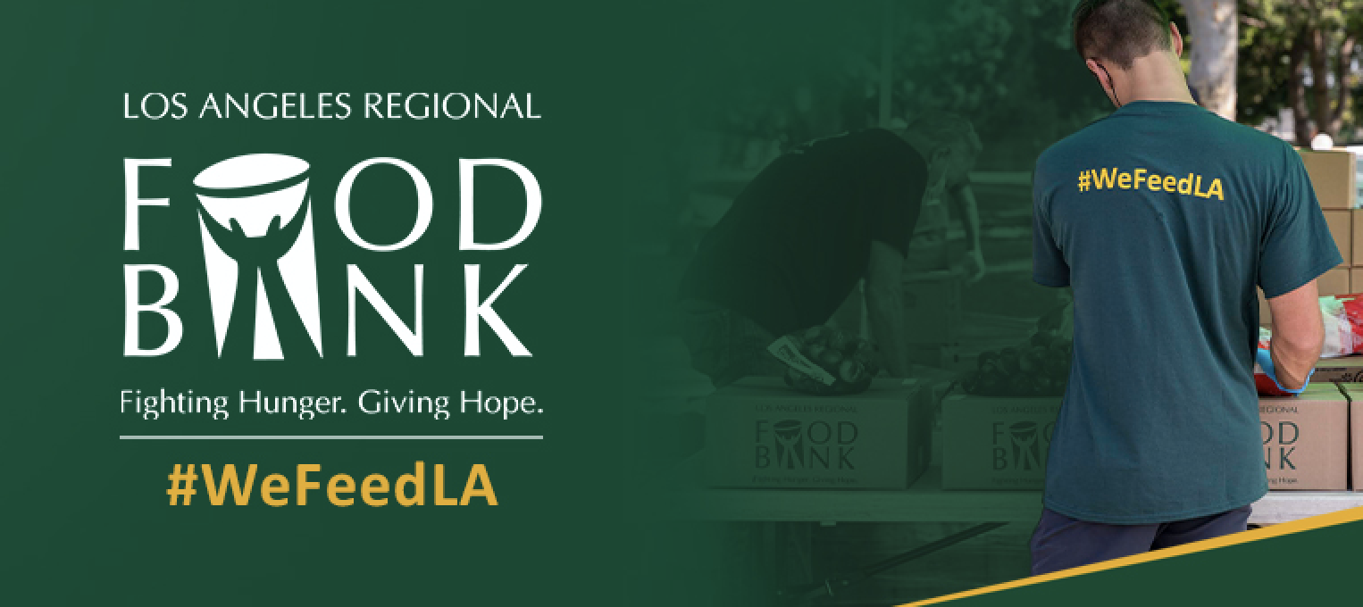
  - Download here: https://www.lafoodbank.org/wp-content/uploads/Facebook-copy.jpg

- 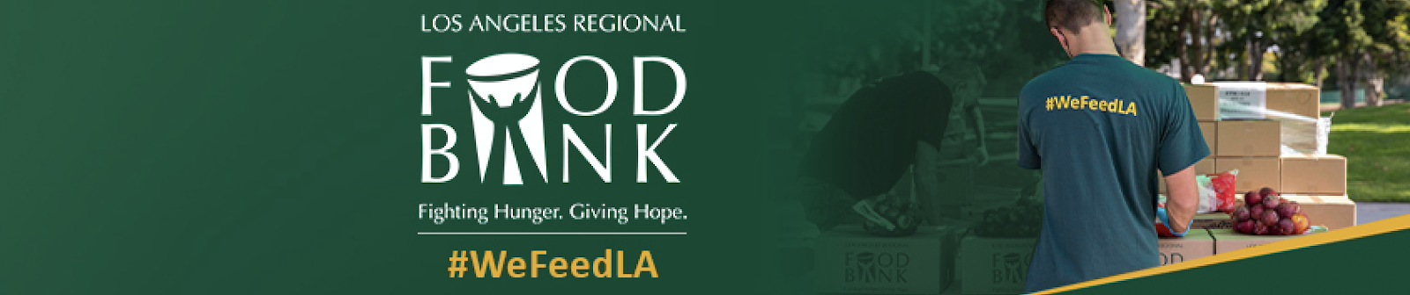
  - Download here: https://www.lafoodbank.org/wp-content/uploads/Linkedin.jpg
- 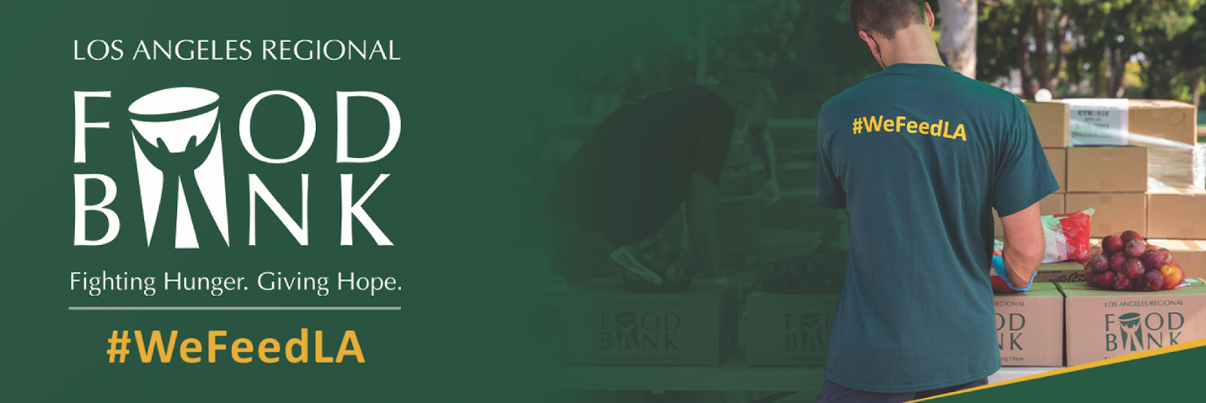
  - Download here: https://www.lafoodbank.org/wp-content/uploads/Twitter.jpg
- 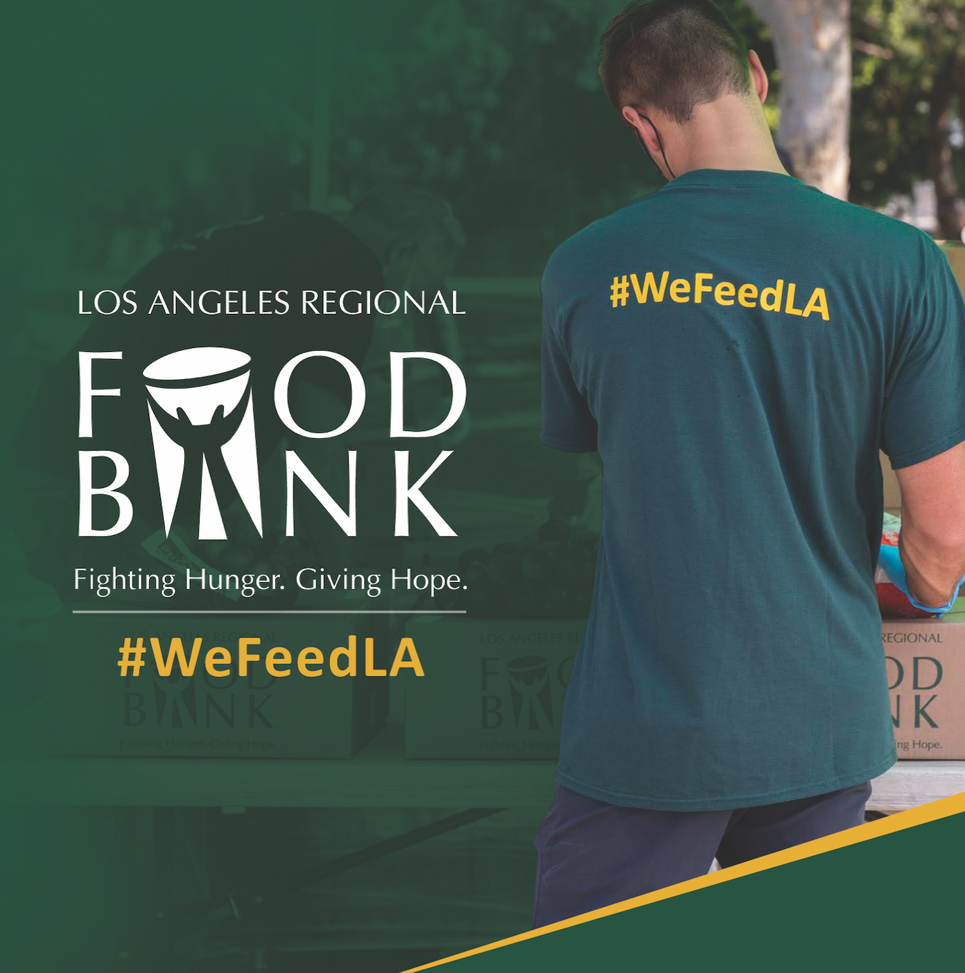
  - Download here: https://www.lafoodbank.org/wp-content/uploads/Social-Media-Post-copy-1.jpg
- Instagram/Facebook Stories: 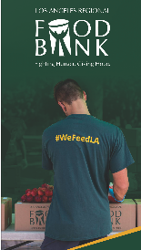
  - Download here: https://www.lafoodbank.org/wp-content/uploads/IG-Story-copy.jpg

