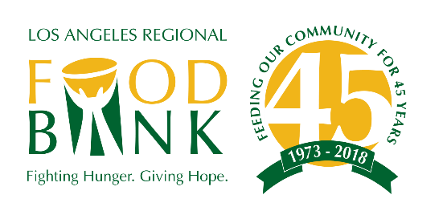

Grant Writing 101:
Some Basic Do’s & Don’ts

- DO Your Research. Does the foundation’s mission and objectives match up with your own? Do you fit within their requirements (e.g. geographic area, population served)? If they have a website, review it for grant guidelines and eligibility requirements. If you have questions, call or send an email unless they do not wish to be contacted!

- DON’T Chase Dollars. It’s tempting to stretch your mission/program description in order to fit what a foundation is seeking. Chasing after money can lead you away from your core work and can end up hurting you in the long run. Don’t waste your time and theirs.

- DO Follow the Guidelines. It’s very important to follow the funder’s instructions exactly. Read through all instructions thoroughly, and have a second person double-check your work before submitting a proposal. Be mindful of maximum numbers of words/characters for online submissions. Do a draft in Word, then copy and paste.

- DON’T leave writing and submitting your application to the last minute! You will need to gather information from multiple source, including program staff, finance/accounting, Human Resources, volunteer staff etc. to provide information that you may not have. Work backwards from the deadline and add in a “cushion” of time prior to submitting.

- Don’t use jargon/acronyms! You and your team will know what they mean, but program officer at a foundation may not. Spell the term in full, then abbreviate it going forward in the rest of your proposal.
Example: “The Food Bank serves approximately 26,000 seniors every month through the Commodity Supplemental Food Program (CSFP).”

/OVER

Grant Writing 101:
Some Basic Do’s & Don’ts (continued)

- DON’T Add Information. Unless the instructions say you can add materials/information, do not include any. Foundations will generally discount unsolicited materials, and not following instructions could count against you.

- DO Tailor Your Proposal. Does the foundation specifically fund programs that serve seniors? Then talk about the seniors that you serve. Wherever you can, highlight the areas where your mission and the foundation’s mission overlap.

- DO Be Specific about What You’ll Accomplish. What’s the impact to your clients and community? Donors want to know exactly what will be accomplished by supporting you. Tell them what you plan to do with their funding and how that translates into helping your clients.

- DO Demonstrate the Need for Your Services. What makes your programs/services unique? Talk about the people that you serve. How do you see them depending on your program? Where possible, use data and stories to paint a picture for your reader.

- DON’T use a messenger/overnight courier service to send your proposal packet. It looks wasteful of your organization’s money. It also shows that you are submitting last minute which reflects a lack of planning.

- DON’T Forget – It’s About Your Clients. At the end of the day, foundations care about who they will be helping with their money. Your clients – their needs and challenges – should always be at the heart of anything you write.

