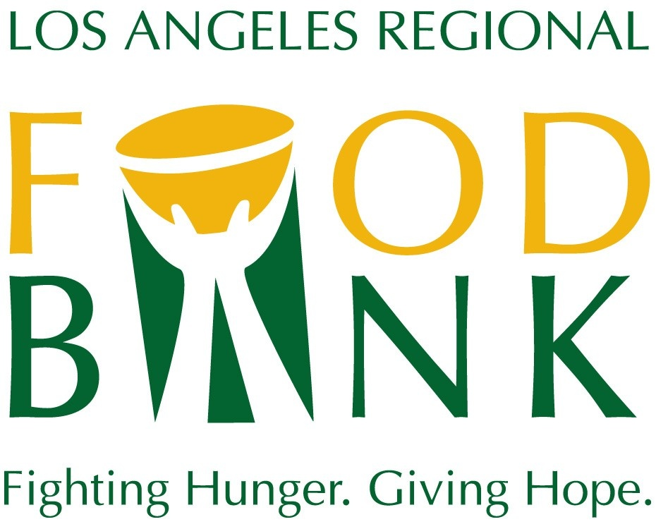
Media Contact:
David May
Director of Marketing & Communications
323.234.3030 ext. 134
dmay@lafoodbank.org

Los Angeles Regional Food Bank
2023 Boilerplate

The Los Angeles Regional Food Bank has been mobilizing resources to fight hunger in Los Angeles County for 50 years. To support the Food Bank’s vision that no one goes hungry in Los Angeles County, food and grocery products are distributed through a network of partner agencies and other Food Bank programs. The Food Bank also energizes the community to get involved and support hunger relief, especially through volunteerism, and conducts nutrition education campaigns and advocates for public policies that benefit people served and improve nutrition security. The Food Bank is rated at the highest level by Candid and Charity Navigator, and 96% of all revenue goes to programs. For more information, visit LAFoodBank.org.

