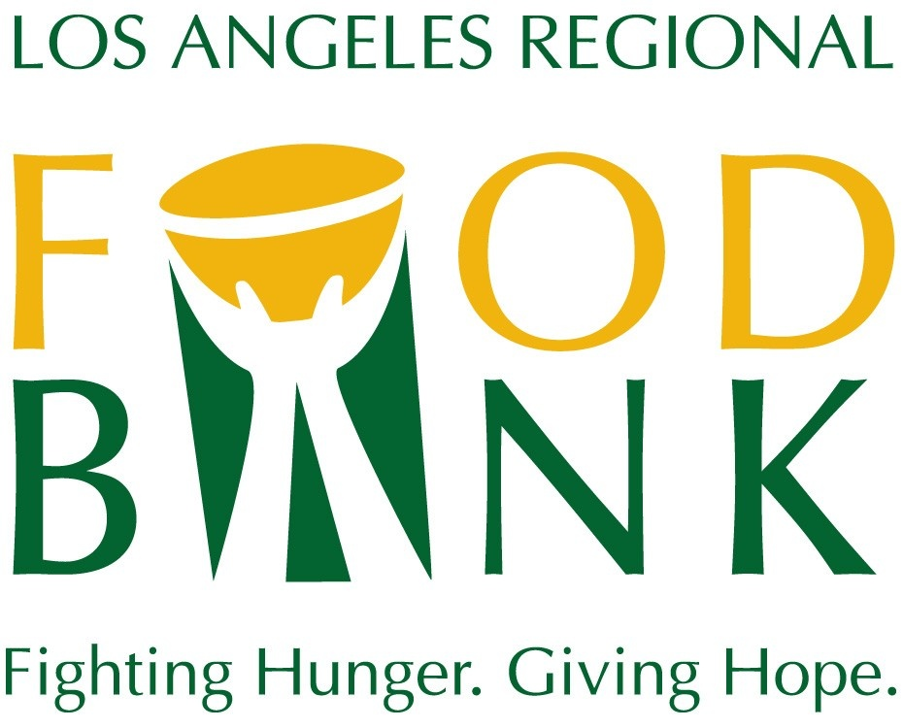
Media Contact:
David May
Director of Marketing & Communications
323.234.3030 ext. 134
dmay@lafoodbank.org

Los Angeles Regional Food Bank
2022 Boilerplate

The Los Angeles Regional Food Bank has been mobilizing resources to fight hunger in Los Angeles County since 1973. To support the Food Bank’s vision that no one goes hungry in Los Angeles County, food and grocery products are distributed through a network of 600+ partner agencies and through Food Bank programs serving 800,000 people monthly. In response to the COVID-19 pandemic, the Food Bank tripled the number of people reached every month. The Food Bank is a 4-star rated charity by Charity Navigator. For more information, visit LAFoodBank.org.

