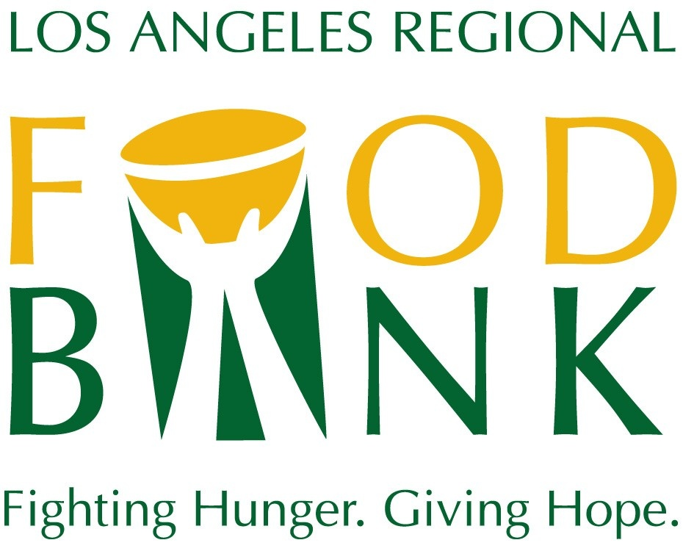
Media Contact:
David May
Director of Marketing & Communications
323.234.3030 ext. 134
dmay@lafoodbank.org

Los Angeles Regional Food Bank
2021 Boilerplate

The Los Angeles Regional Food Bank has been mobilizing resources to fight hunger in Los Angeles County since 1973. To support the Food Bank’s vision that no one goes hungry in Los Angeles County, food and grocery products are distributed through a network of 700 partner agencies and directly to those in need through Food Bank programs. The Food Bank has distributed more than 1.7 billion pounds of food, the equivalent of 1.35 billion meals, since 1973. The total value of food and grocery product distributed since the Food Bank’s inception is $2.3 billion. In response to the COVID-19 pandemic, the Food Bank tripled the number of people helped, and now reaches 900,000 people every month. The Food Bank is a 4-star rated charity by Charity Navigator. For more information, visit LAFoodBank.org.

