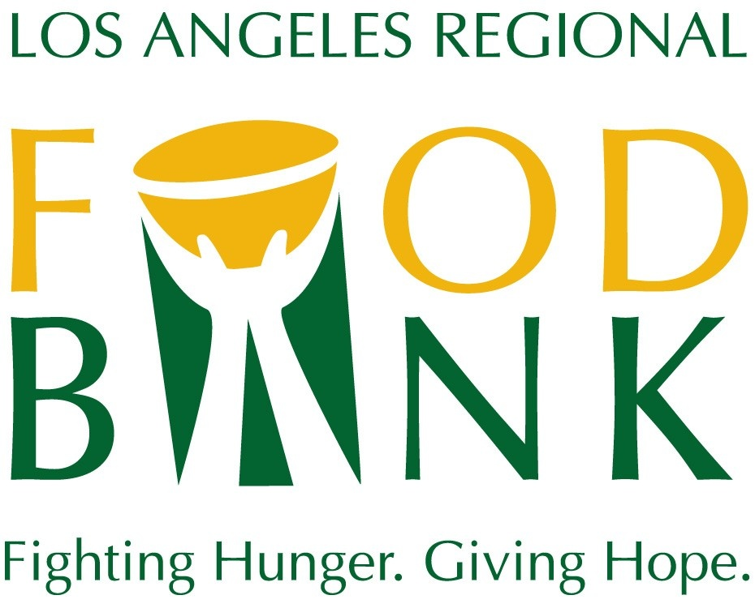
Media Contact:
David May
Director of Marketing & Communications
323.234.3030 ext. 134
dmay@lafoodbank.org

Los Angeles Regional Food Bank
2020 Boilerplate

The Los Angeles Regional Food Bank has been mobilizing resources to fight hunger in Los Angeles County since 1973. To support the Food Bank’s vision that no one goes hungry in Los Angeles County, food and grocery products are distributed through a network of 700 partner agencies and directly to families, seniors and children through direct distribution programs. The Food Bank has distributed more than 1.5 billion pounds of food, the equivalent of 1.2 billion meals since 1973. In response to the Coronavirus crisis, the Food Bank has more than doubled food distribution, and now reaches more than 900,000 people every month. The Food Bank is a 4-star rated charity by Charity Navigator. For more information, visit LAFoodBank.org.

