Los Angeles Regional Food Bank
Publication Style Manual and Glossary

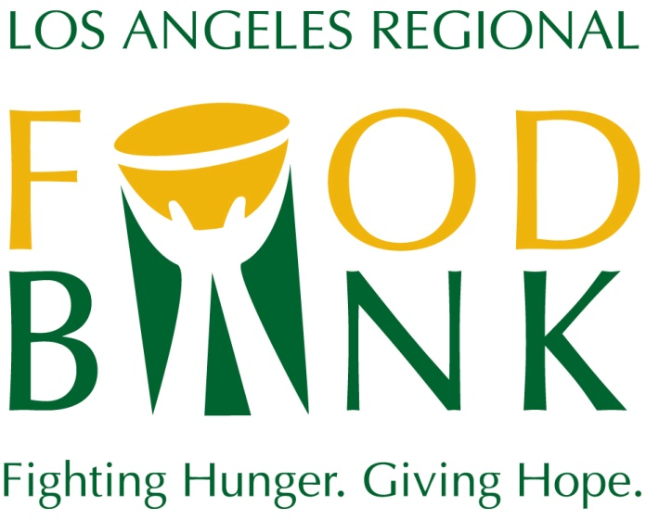

Revised March 2014

The following are style preferences, rules and guidelines for frequently used terms at the Los Angeles Regional Food Bank. They also address some of the most frequently raised questions of style.
These guidelines should be followed in Food Bank publications and signage.
We should always strive to have all presentations of the Food Bank be of the highest quality.

Contents

Mission
Vision
Food Bank Name
Addresses
Dates
Electronic Media Terms
Governing Boards
Numbers
Punctuation
Font
Acronyms and Programs
Logo Use Standards

Mission

To mobilize resources to fight hunger in our community.

To fulfill our mission we:
Source and acquire food and other products, and distribute to needy people through charitable agencies or directly through programs.
Energize the community to get involved and support hunger relief.
Conduct hunger education and awareness campaigns and advocate for public policies that alleviate hunger.

Vision

No one goes hungry in Los Angeles County

Food Bank name

Full proper name is: Los Angeles Regional Food Bank
On second reference you may use Food Bank.
Food Bank is two words
When referring to the Food Bank always capitalize “Food” and “Bank”
Acceptable to use: L.A. Regional Food Bank
NEVER use LARFB or LA Food Bank or L.A. Food Bank

Address

Our main address is:
1734 E. 41st Street
Los Angeles, CA 90058
- Use this address for all mailing to 1734 and 1701.

To direct people to the 54th Street warehouse the address is:
2825 E. 54th Street, Vernon, CA 90058
Abbreviate and use numerals in specific addresses.
- Spell out and follow the normal style rule for numbers when making a general reference to a street.
- Abbreviate building when giving a room number, but spell it out in a general reference.
- Always spell out Route and Highway.

Dates

Use month with number for specific dates.
- Example - Jan. 2, 2013
- NEVER use 1-02, Jan. 2ndJan. 2, 13
Abbreviate names of months more than five letters long when followed by a date, but spell out when referring to the month generally.
- DO NOT abbreviate March, April, May, June, July.
Use Monday, Tuesday, etc. for days of the week within seven days before or after current date. Use today as appropriate for current work. DO NOT use yesterday or tomorrow.

Electronic Media Terms

Use lafoodbank.org when referring to the website, NOT www.lafoodbank.org

Proper spelling and capitalization for common terms
blog
database
email
Facebook
Homepage
Google
google (not capitalized when used like a verb)
Instagram
Internet
log in (verb)
login (adj. or noun)
online
password
PDF
Pinterest
Podcast
Social media
Tweet
Twitter
Username
Web
Webcast
Webpage
website
YouTube

Governing Boards
The Food Bank has several governing boards. The proper names should be capitalized.
The boards are headed by a chairperson, NOT chairman or chairwoman
Board of Directors
Advisory Board

Numbers

Use figures for all numbers above nine; spell out all numbers under 10.
Here are the exceptions:
- Use figures for ages, sums of money, time of day, percentages, house numerals, years, days of month, degrees of temperature, proportions, votes, scores, speeds, time of races, dimensions and serial numbers. Note: We do use “$1 = 4 meals.”
- Spell out numbers, no matter how large, when they begin sentences; rephrase the sentence if long numbers are awkward. Exception: When starting a sentence with a year, do not write it out.
1999 was a very good year.
- Use figures for ordinal numbers above ninth; spell out ordinals under 10th.
Ninth 21st 156th 192nd 21st century
Use 21 million instead of 21,000,000. Also: $39 million, $22.5 billion. Don’t carry beyond two decimals. Avoid unnecessary ciphers. Use $1, not $1.00; 1 p.m., not 1:00 p.m.
Fractions standing alone are spelled out.
Insert commas with four or more figures, except in dates.
Example - $5,900 1,576 skateboards 1990 2001
Punctuation

The purpose of punctuation is to clarify meaning.

Periods
Put the period inside brackets or parentheses when a complete sentence is enclosed in the brackets or parentheses. When the parenthetical expression forms only a part of the sentence, put the period outside the bracket or parenthesis.
- (The day was too cold for football.)
- The day was too cold for football (or skiing).
Always put the period and comma inside quotation marks. Put other punctuation marks inside when they are part of the quoted material.

Comma
The comma, aside from its technical uses in mathematical, bibliographical, and other contexts, indicates the smallest break in sentence structure. Especially in spoken contexts, it usually denotes a slight pause. In formal prose, however, logical considerations come first. Effective use of the comma involves good judgment, with ease of reading the end in view.

- When listing items you do not need a comma before the word “and.”
Example: I like red, white and blue.
NOT: I like red, white, and blue

Title abbreviations following a name, such as Jr., Sr,. Esq. are NOT set off by commas

In dates, commas are not used to mark off the month and the year. If the day is included, the year is set off by a comma before and after.
Example: The meeting is in June 2013
Example: The meeting on June 18, 2013, will be about volunteers.

Quotation marks
Quotation marks should be outside of all punctuation
Example: “We are very busy today,” she said.
NOT: “We are very busy today”, she said.
Font

Font for most brochures and printed materials is Calibri. Special fonts may be used by the communications department for special events.
Glossary of Acronyms and Programs
GLOSSARY OF ACRONYMS AND PROGRAMS

GLOSSARY OF ACRONYMS AND PROGRAMS

After School Meal – Distributed at Kids Café sites the “meal” is served after school.
BackPack Program (One word. Capital “B” and “P”) - Kids get food on Friday afternoon to help them through the weekend.
Brown Bag Program – Seniors receive food on a weekly basis. Food is from private donors.
California Association of Food Banks – Provides a unified voice among food banks to maximize their ability to help Californians. We are one of 41 members.
CalFresh (One word with capital “C” and “F.”) - Program formerly known as Food Stamps.
CSFP - (Commodity Supplemental Food Program) Targeted to seniors, pregnant women and new mothers. Participants receive one of six age-appropriate food kits monthly.
EFAP (Emergency Food Assistance Program) - Provides United States Department of Agriculture (USDA) commodities to a network of food banks for distribution to eligible individuals and households within their service area.
EFF (Emergency Food Fund) – To supplement donated inventory the Food bank used this fund to purchase high-demand, nutritious food and pay for its distribution.
Extra Helpings – The Food Bank pairs caterers, restaurants and other with local agencies to distribute perishable food.
Feeding America – A national organizations that advocates for food banks and hunger awareness.
FEMA (Federal Emergency Management Administration)
Food From the Bar – Yearly money and food drive conducted by law firms in Los Angeles.
Food From The Bar Kickoff – kickoff is one word as a noun or adjective and kick off as a verb.
Food Drives / Virtual Food Drives – Always capitalized.
Food security – Refers to the availability of food and one's access to it. A household is considered food-secure when its occupants do.
HATCH – Hollywood Agencies Together Combat Hunger
HEAL - Seniors receive food on a weekly basis. Food is from private donors.
GAAP –
Kids Cafe - Locations where After School Meal and Summer meal programs are served.
Mobile Food Pantry – A specialized truck designed to transport and distribute food .
RFD (Rapid Food Distribution) – Enables the Food Bank to get highly nutritious, perishable fruits and vegetables out to our agencies just in time for distribution. This program uses the Food Bank’s refrigerated beverage truck to transport fresh, perishable foods to agencies that have very limited refrigeration.
SFSP (Summer Food Service Program) – Provides nutritious lunches to sites during the summer.
SNAP ( Supplemental Nutrition Assistance Program) - Formerly known as the Food Stamp program, provides financial assistance for purchasing food to low- and no-income people living in the U.S. It is a federal aid program, administered by the U.S. Department of Agriculture, though benefits are distributed by individual states.
TEFAP (The Emergency Food Assistance Program) – A Federal program that helps supplement the diets of low-income needy persons by providing them with emergency food and nutrition assistance.
USDA (United States Department of Agriculture)

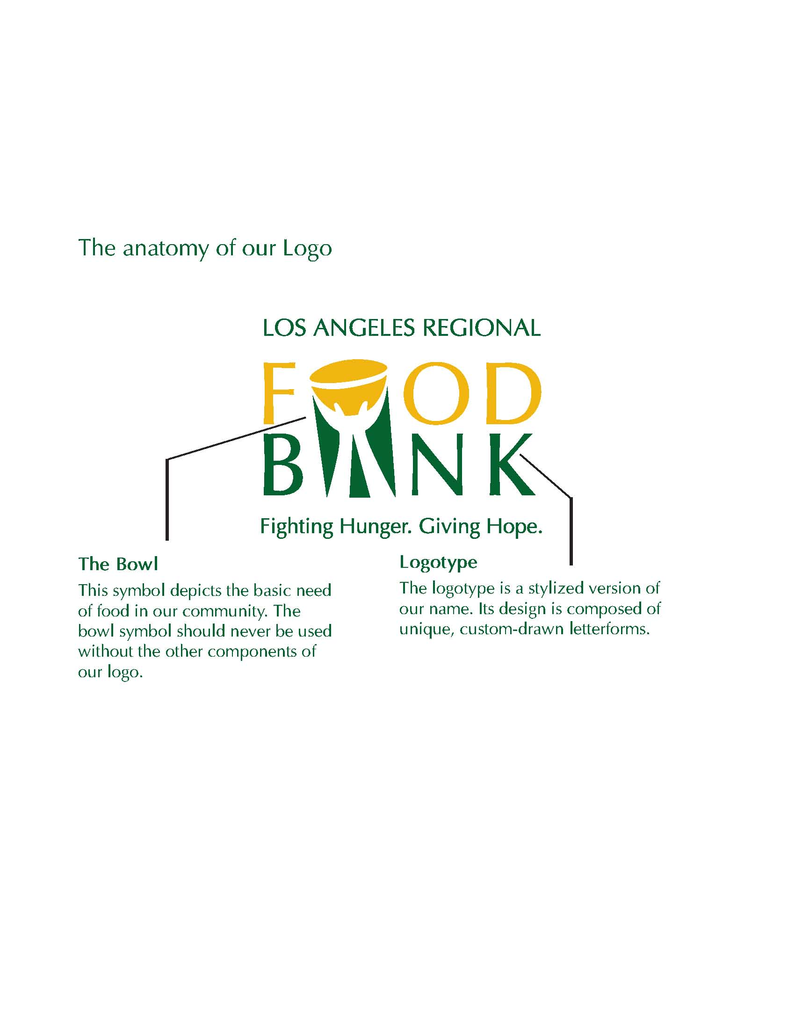
Logo Usage Standards

GLOSSARY OF ACRONYMS AND PROGRAMS

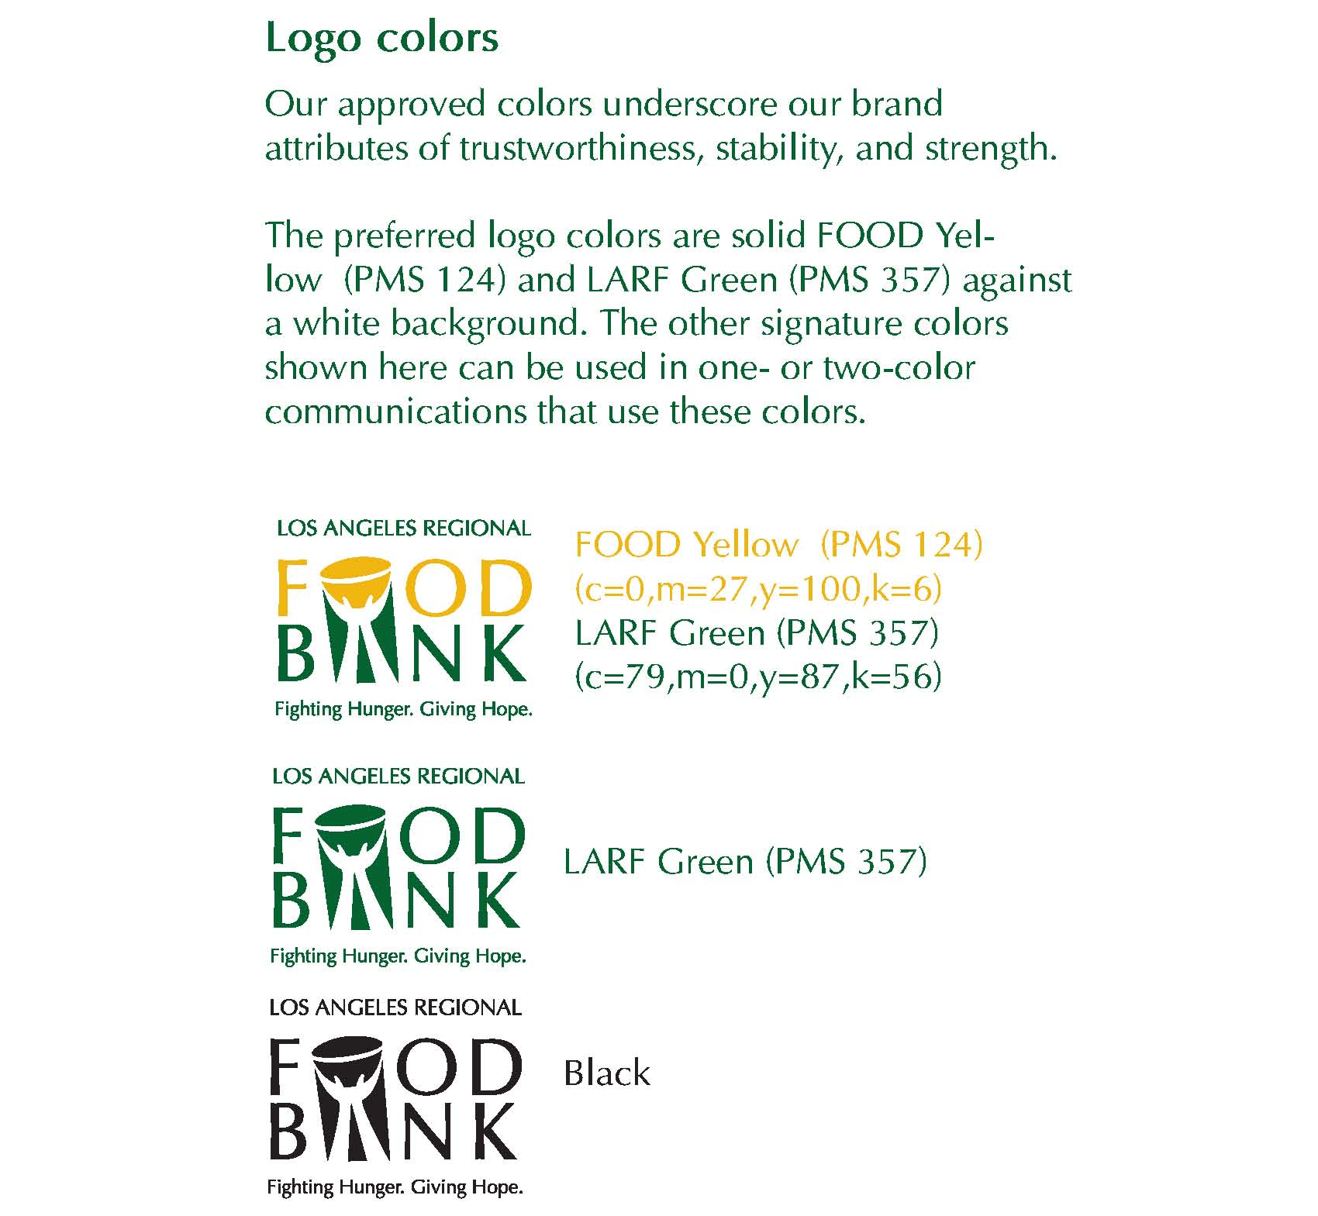
Additional Logo Color Information
Yellow RGB & Hex
- R: 238
- G: 178
- B: 16
- Hex: EEB210
Green RGB & Hex
- R: 0
- G: 99
- B: 48
- Hex: 006330

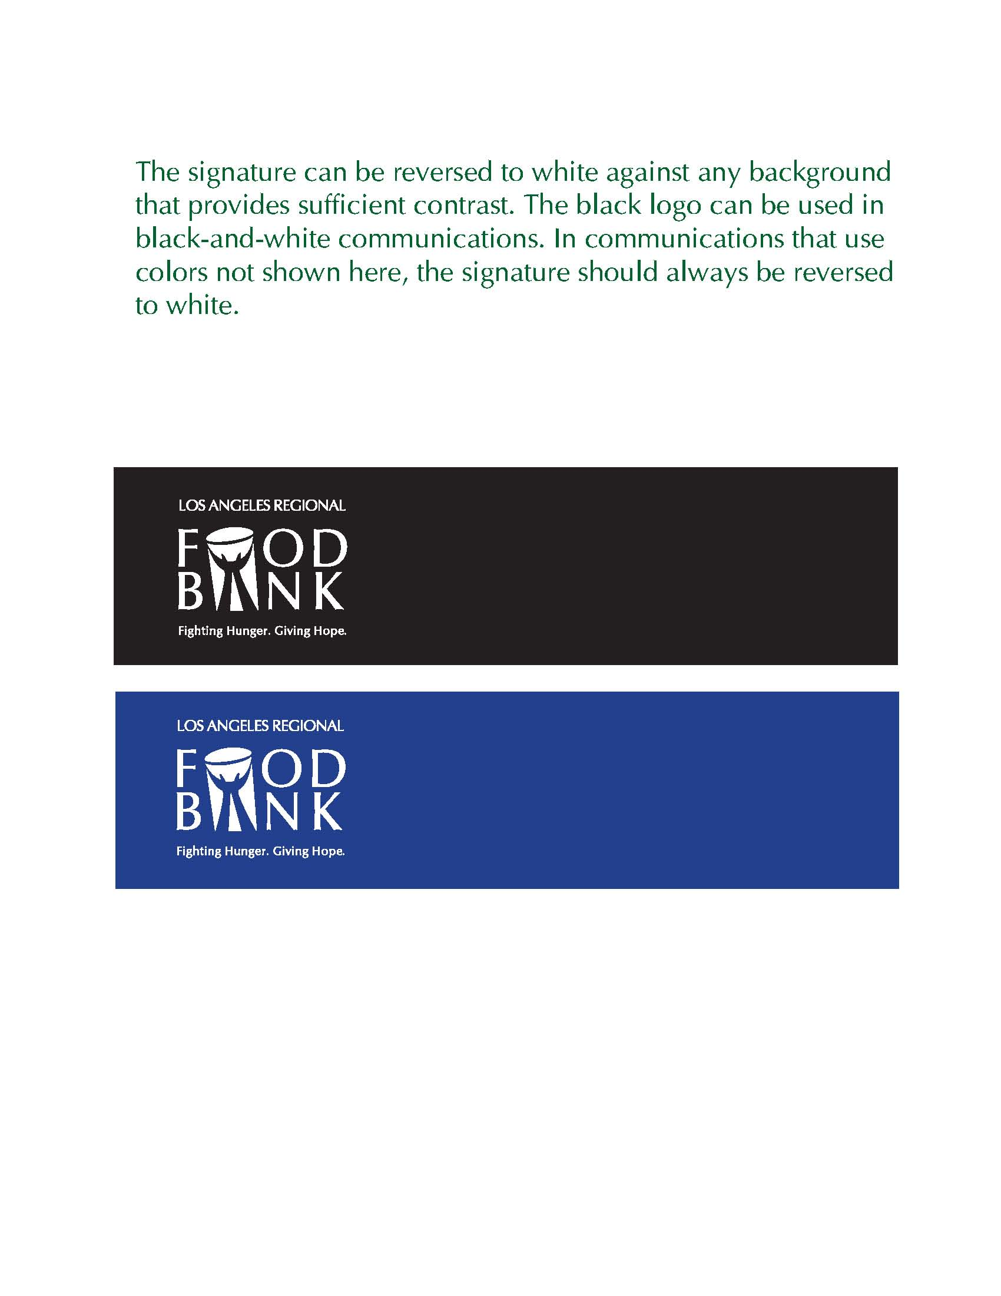

Specialty Logos, such as the 40th Anniversary Logo, are approved variations of the Food Bank logo that are used for specific campaigns and should not be used for any other purpose. The logo should not be split apart, nor should the colors be altered.

